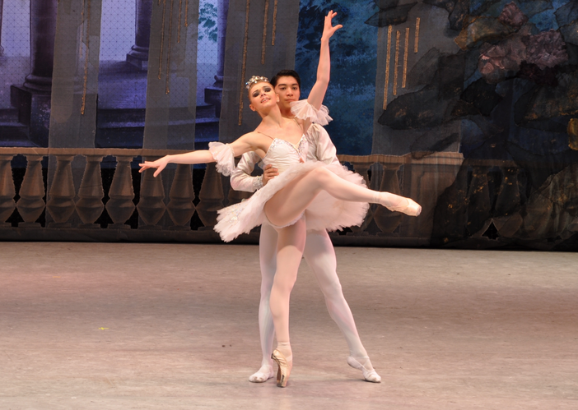

**Moscow Festival Ballet: *Romeo and Juliet* & *The Sleeping Beauty***

**Live at Wharton Center January 8**

Born in 1944, Sergei Radchenko graduated from the Moscow School of Dance in 1964 and then worked for the Bolshoi Ballet for 25 years, where he achieved the role of principal and danced the company’s complete repertoire. Desiring to capitalize on the immense Russian talent in the classical ballets, he created the Moscow Festival Ballet, an independent company combining the highest classical elements of the Bolshoi Ballet and Kirov Ballet.

The company offers a diverse repertoire, specializing in twentieth century full length-ballets such as *Cinderella, Romeo and Juliet,* and *Legend of Love.* In 2000, Radchenko also researched the original choreography and stage productions of Marius Petipa’s classic ballets and produced new productions of *Don Quixote* and *Paquita*, along with a recreation of Jules Perrot’s and Jean Coralli’s *Giselle*. With their diverse repertoire, Moscow Festival Ballet has toured extensively in Europe, United Kingdom, Turkey, Asia, and North America.

Moscow Festival Ballet will be returning to the United States in 2016 and will be performing at the Wharton Center for Performing Arts in East Lansing, MI on Friday, January 8, 2016 at 8pm. The performance will include *Romeo and Juliet,* Shakespeare’s classic tale of star-crossed lovers with music by Tchaikovsky and choreography of Petipa. The company will also perform selections from the fairytale *The Sleeping Beauty,* also with music by Tchaikovsky. Both works will be performed in the grand ballet style with exquisite costumes and lush scenery. For more details about the performance and to purchase tickets, please visit whartoncenter.com or call 1-800-WHARTON.