September 23, 2016

To Whom It May Concern,

Laura was an immense help to me this summer. She spent three months here at Live Nation, alternating between office work and helping onsite at shows.

After her first day in the office I knew I’d be able to trust her. She is an incredibly organized person with a passion for the work she does, and professionalism beyond her years. In the live music marketing world our jobs are different every day, and Laura adapted surprisingly quickly for only being in the office twice a week; she tackled everything I threw at her and was not afraid to ask questions.

But the thing I loved most was her effective management of our social media accounts. Because summertime is so chaotic and Laura is so trustworthy, I handed all Live Nation Detroit social accounts over to her and pretty much said, “go for it!”

And it was the right move. My social media skills are no match for hers! She was surprisingly creative with post copy (including snapchat graphics) and her iPhone camera skills are amazing. Her photo of Blake Shelton’s surprise appearance at our Gwen Stefani show made it onto billboard.com and Gwen Stefani’s Instagram!

Our snapchat following grew at a crazy rate and the amount of twitter engagements she garnered with her live, as-it-happens show tweets was through the roof!

Laura wanted to absorb as much as possible during her time here; she had no problem working long hours, staying for entire shows (even if she wasn’t a fan of the performer) just to make sure she got as much content as possible.

She also used our post-scheduling software to make sure we didn’t miss a day of posting, even when there wasn’t a show happening. She went above and beyond with this.

Thankfully she won’t be graduating college next year, so we can have her back next summer!

Sincerely,

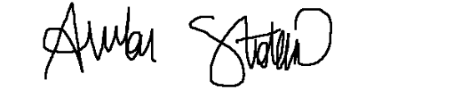

**Amber Stokosa**

Marketing Coordinator, Live Nation Entertainment - Detroit