**‘Sound of Music’ Cast: Where Are They Now?**

**Celebrating the Anniversary of the 1965 Film**

This year marks the 50th anniversary of the film “The Sound of Music,” which first captivated audiences in 1965 with the real life story of the renowned Von Trapp Family singers. Set in 1930s Austria, the story follows Maria, (Julie Andrews) whose failed attempt to join a convent leads her to becoming a governess for the widowed Captain Von Trapp (Christopher Plummer) and his seven children. Although resentful of past governesses, the children eventually appreciate the kindness, understanding, and much-needed joy Maria brings to their lives – including the Captain’s. Maria and Captain Von Trapp begin falling helplessly in love, even though the Captain is engaged to a Baroness and Maria is still a postulant. Their personal conflicts are soon overshadowed by Germany’s imminent takeover of Austria and the threat of the German army drafting the Captain to fight against Austria.

To celebrate the anniversary of one of the most commercially successful films of all time, we decided to take a look at what the original cast is up to 50 years since the film’s 1965 release.

**Julie Andrews: Maria**

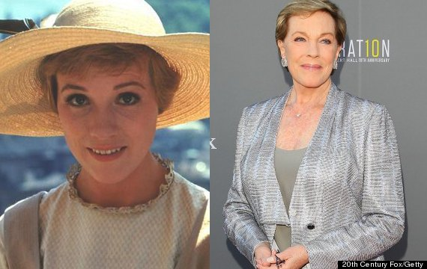

Since winning a Golden Globe Award for Best Actress in a Musical for her role as Maria, Andrews went on to star in several of her husband’s (Blake Edwards) films, including *10,* *S.O.B* and *Victor/Victoria*. During the Broadway run of *Victor/Victoria,* her vocal range was permanently damaged in an operation, leaving her unable to sing. However, she continued to act in the 1980s and 1990s in some critically acclaimed but less commercial movies such as *That’s Life* and *Duet for One.* She even starred in her own short-lived sitcom. In the 2000s, her commercial popularity resurged with her involvement in *The Princess Diaries* franchise as Queen Clarisse Marie Renaldi, where she starred alongside Anne Hathaway. In recent years, Andrews has authored several children’s books and has lent her voice to several animated films, including *Shrek 2* (2004), *Shrek the Third* (2007), *Enchanted* (2007), *Shrek Forever After* (2010) and *Despicable Me* (2010). Andrews has received numerous accolades for her work, including an Academy Award, a BAFTA, five Golden Globes, three Grammy, two Emmys, the Disney Legend honor, the Kennedy Center Honors and was named a Dame by Queen Elizabeth II for services to the performing arts. Andrews is currently 79 years old.

**Christopher Plummer: Captain Von Trapp**

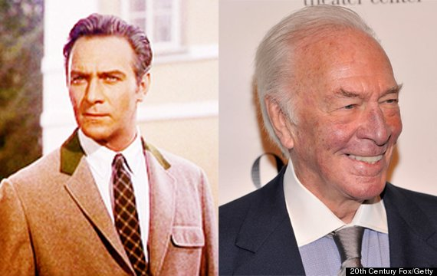

After the release of “The Sound of Music,” Plummer has gone on to have a wildly successful career in film, television, and theatre spanning over five decades. Some of his notable film performances include *Waterloo* (1970), *The Return of the Pink Panther* (1975), *Murder by Decree* (1979), *Star Trek VI: The Undiscovered Country* (1991), *A Beautiful Mind* (2001), *Nicholas Nickleby* (2002), *The New World* (2005), *Inside Man* (2006), *Up* (2009), *The Imaginarium of Doctor Parnassus* (2009), and *The Girl with the Dragon Tattoo* (2011). He has also played several famous historical figures, including Rudyard Kipling in *The Man Who Would Be King* (1975), Mike Wallace in *The Insider* (1999) and Leo Tolstoy in *The Last Station.* Plummer also starred in the lead roles of stage productions of *Cyrano* and *Barrymore*, winning Tony awards for both and receiving five nominations for his additional roles. He has also been awarded an Academy Award, two Emmy awards, two Tony Awards, a Golden Globe Award, a SAG award, and a BAFTA award for his work. Plummer is currently 85 years old.

**Nicholas Hammond: Friedrich**

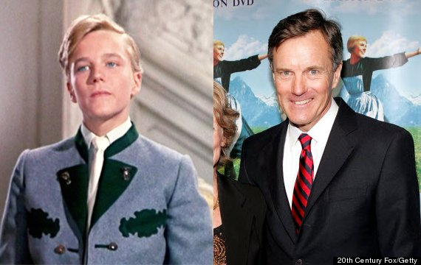

After starring as Fredrich, the second eldest Von Trapp son, Hammond went on to guest star in several television shows, including *The Brady Bunch*, *The Waltons,* *The Love Boat*, *Magnum P.I.*, *Murder*, *She Wrote*, *Falcon Crest*, and *Dallas.* He also spent several seasons on *General Hospital* and the 1970s *Hawaii Five-0.* More notably, Hammond starred as Peter Parker in The Amazing Spider-Man CBS TV series from 1977 to mid 1979. Hammond is currently 65 years old.

**Kym Karath: Gretl**

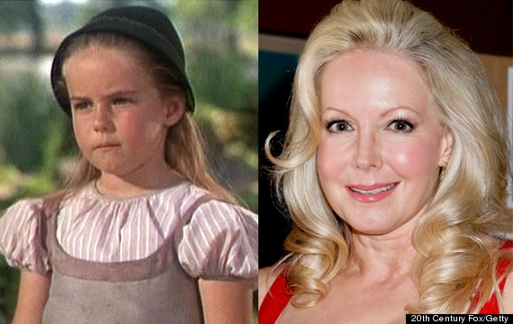

Karath starred as the youngest of the seven Von Trapp children and has continued acting in television shows including *Dr. Kildare* (1961), *Lassie* (1954), *My Three Sons* (1960), *Lost in Space* (1965), *Family Affair* (1966) and *The Brady Bunch* (1969). She then took some time off to pursue a degree in the Humanities from USC. Karath then went on to appear in television shows such as *Archie Bunker’s Place* (1979) and *Midnight Offering* (1981) before moving to Paris to model and study art history. She would then return to the United States and appear on *All My Children* before taking time off to raise her son, Eric. She is now resuming her acting career in Los Angeles.

Witness this class film come to life in an all-new musical production of “The Sound of Music,” directed by three-time Tony Award winner Jack O’Brien, February 9-14, 2016 at the Wharton Center for Performing Arts. This production has thrilled audiences with its Tony, Grammy, and Academy Awards winning Best Score for beloved classics including “My Favorite Things,’ “Do-Re-Mi,” and “Edelweiss.” For more information and to purchase tickets, visit whartoncenter.com or call 1-800-WHARTON.