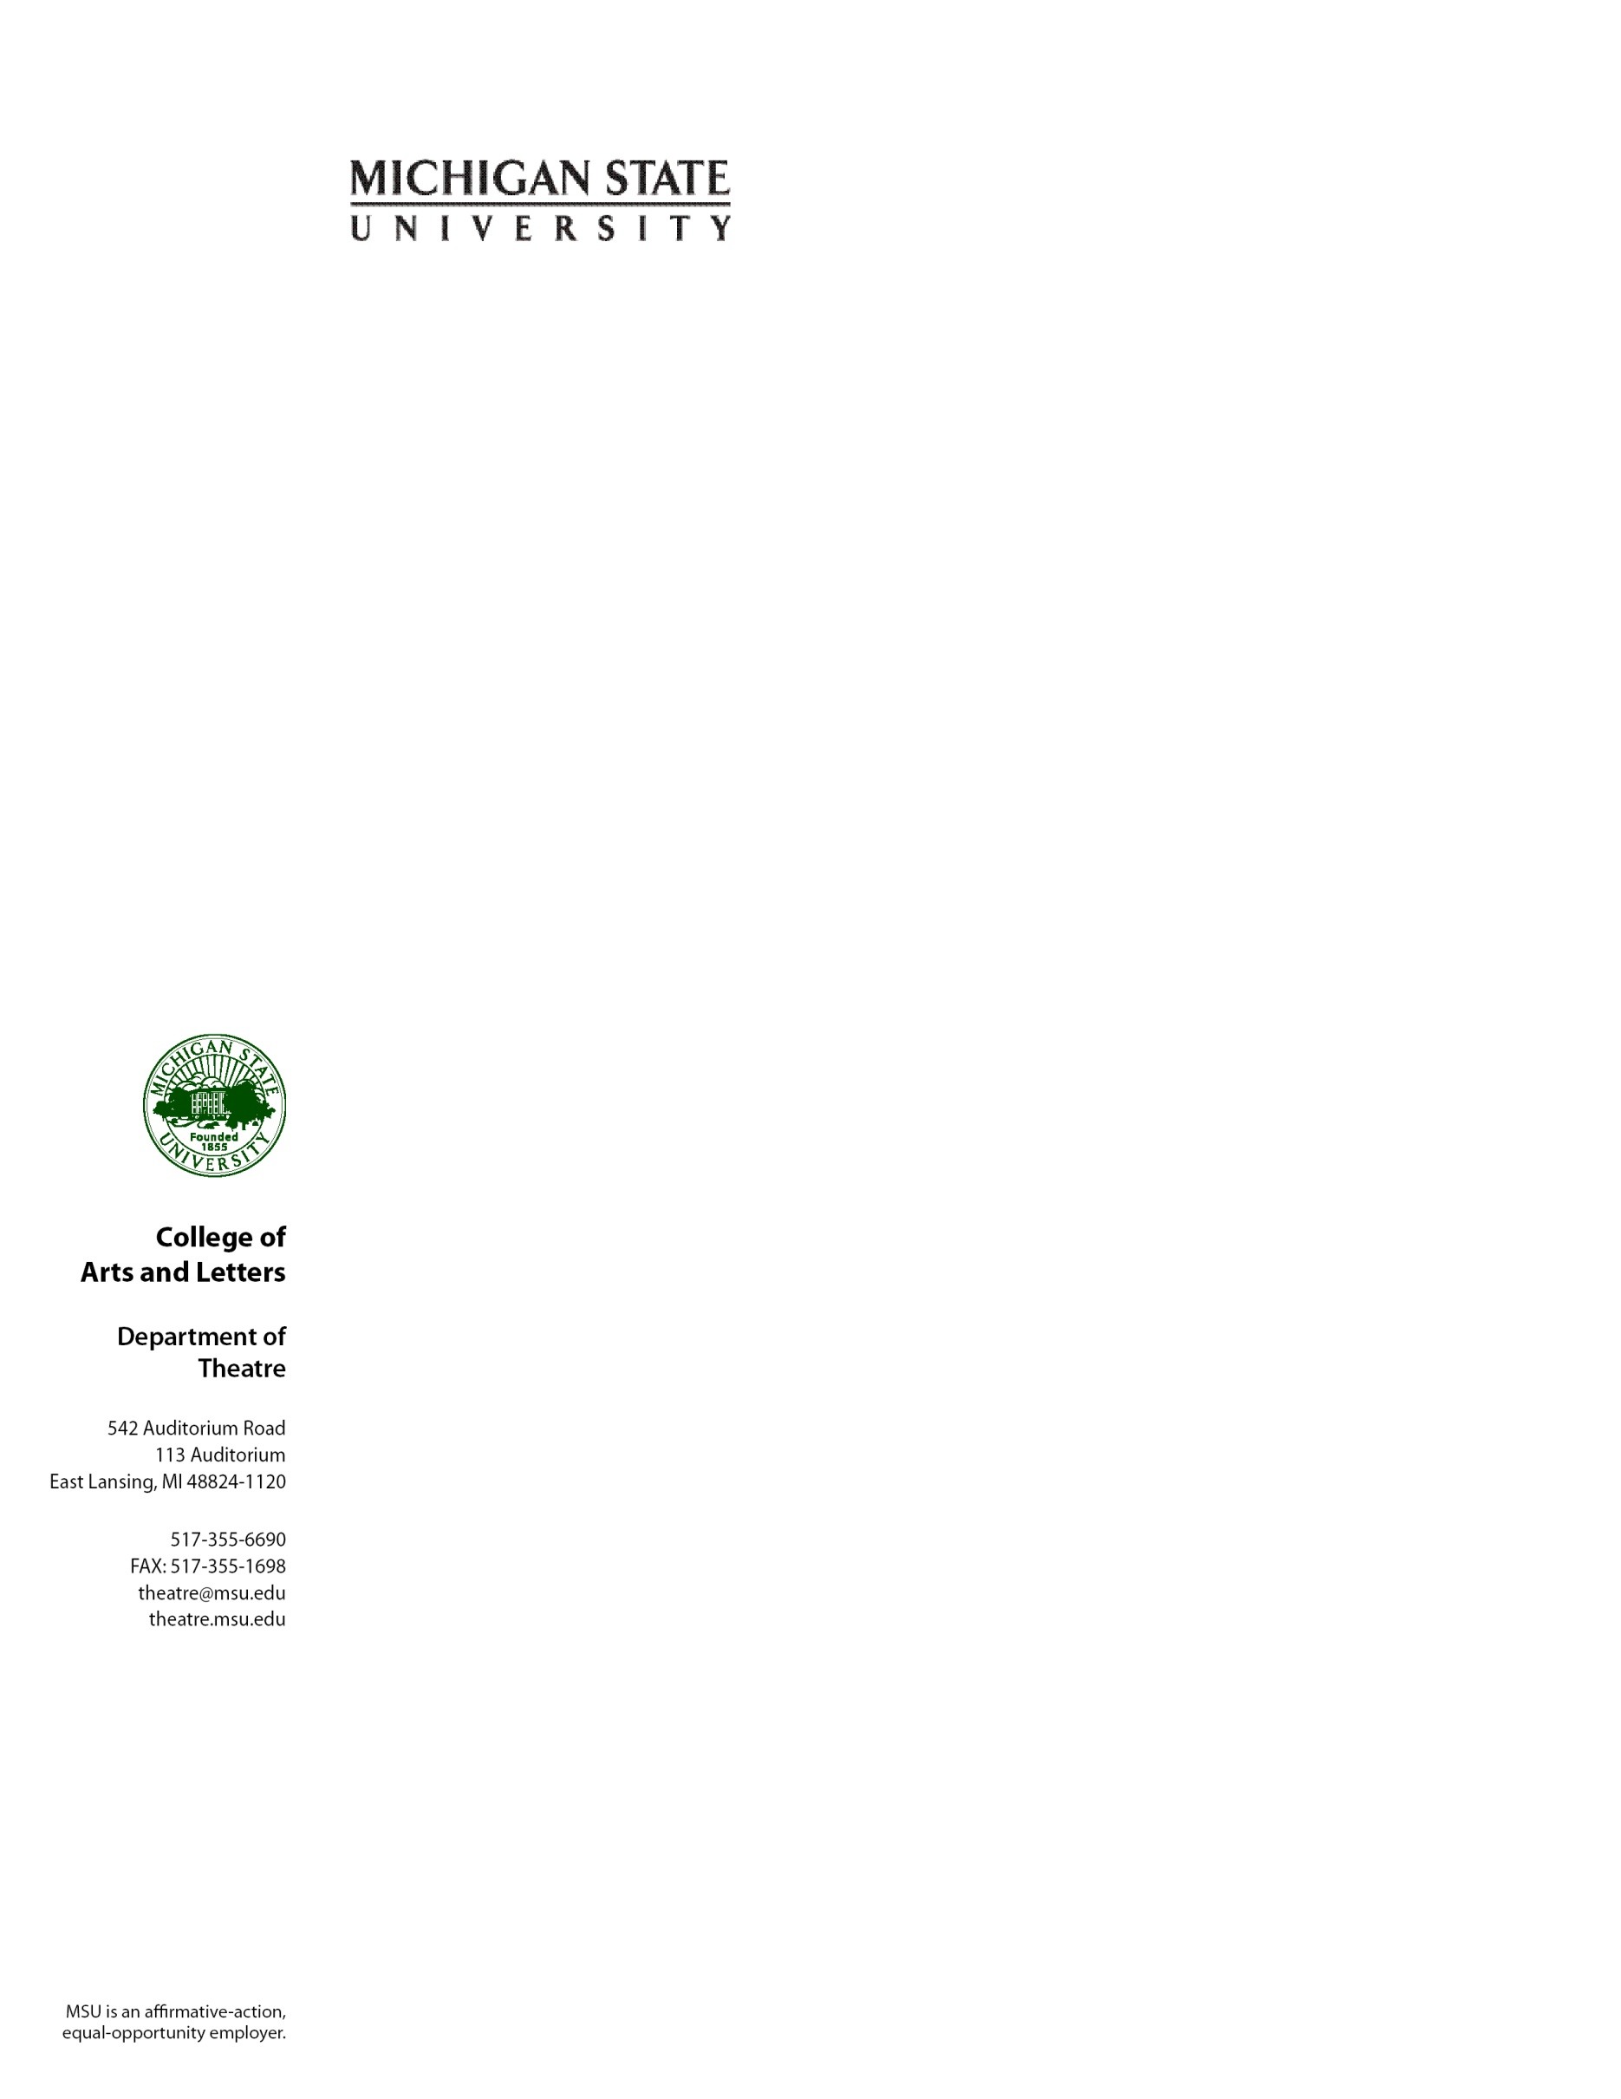

January 2018

To Whom It May Concern:

It is my sincere pleasure to recommend Laura Kring for a position within your organization. I have gotten to know Laura quite well over the past few semesters, and I can say without hesitation that she will be an invaluable asset to your program. Laura is probably one of the most dedicated and hard working students I have ever had the pleasure of teaching. She’s smart, quick, passionate, and the most thorough when it comes to any and all details.

Ms. Kring is a prime example of what we wish to see in all of our students: she’s compassionate, collaborative, supportive, hardworking, dedicated, and eager to learn, explore, and question. Laura works extremely hard and it shows; as an example, she’s a member of the student marketing team for the performing arts theatre on campus and, knowing their staff quite well, I hear nothing but compliments about her. When they are looking for new hires I always hear “Do you know anyone like Laura?” She sets the bar quite high wherever she works. She also has a calm, mature demeanor, which is quite refreshing when working in the highly stressful environment of live events and the performing arts. Having spent 25 years working professionally within these industries, I know the type of personality one wishes for on their team, Laura more than fits the bill.

Please do not hesitate to contact me if you have any questions or would wish for me to expand on this reference. I truly believe in Ms. Kring and I know that when you bring her on to your team, you too will find her to be exceptional. I can unequivocally recommend her for employment with your organization.

Sincerely,

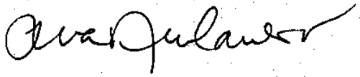

Tina M. Newhauser

Arts & Cultural Management

Department of Theatre

College of Arts & Letters

Michigan State University

542 Auditorium Rd. rm 201

East Lansing, MI  48824

517-884-7793