**Executive Summary**

Two main goals were established for the East Lansing Hannah Community Center AdWords campaign: 1) increase community awareness for their services and 2) drive action through conversions. To accomplish these goals, our project was divided into three main campaigns focusing on the community center’s core offerings: fitness passes, group exercise, and visual and performing arts. To chart our progress towards our two primary goals, we used several KPIs, including impressions, clicks, and CTR. Our initial goals for our KPIs at the beginning of the campaign included an overall 8.75% CTR, 175 clicks across all campaigns, and 2,000 overall impressions. At the conclusion of the three weeks and with our $214 budget, our three campaigns achieved a combined 209 clicks, 3,734 impressions, 5.60% CTR, and $1.02 average cost per click. In comparison to our initial goals, our project did not reach the desired CTR, however, the campaigns exceeded the estimated number of clicks and impressions. In terms of specific ad group performance, the highest performing ad group (Gym Membership) achieved 51 clicks and 1,074 impressions, and a CTR of 4.75%, while the weakest performing ad group (Fitness Classes) earned 1 click and 22 impressions, and a 4.55% CTR.

Our overall performance demonstrates how Google AdWords can provide a substantial return on investment for businesses looking to improve their online presence. With our small budget of $214, our ads received 3,734 impressions, along with 209 additional clicks to the community center’s website. These clicks likely generated additional conversions for the community center in the form of brochure downloads, account registration, and membership and class purchases, resulting in a substantial return on the initial investment of $214.

In terms of future marketing recommendations, we suggest the community center optimize our current AdWords strategy to generate a greater ROI. The most significant portion of the budget should be allocated to the fitness passes campaign because it generated the most reach and conversions. Additionally, Hannah Community Center should continue to run the following ad groups: sports leagues, swim lessons, visuals arts and dance, as they all had high performance for the campaign KPIs. The community center should also capitalize on the seasonality of their offerings to achieve maximum ROI. Beyond Google AdWords, we recommend the community center modify their website to aid in the analytics of tracking clicks and simplify the site experience for users through the elimination of the double registration.

**Industry Component**

The two primary goals of the AdWords campaign were to increase community awareness for the services offered by the East Lansing Hannah Community Center and drive action with conversions via CTRs to the community center’s website, along with clicks to landing pages for account creation, brochure downloads, and membership and class purchases. Our account ran three campaigns focusing on the organization’s three core products: 1) fitness passes 2) group exercise and 3) visual and performing arts. To chart our progress towards our goals, we used impressions, clicks, and CTRs as our KPIs with the goal of achieving an 8.75% CTR, 175 clicks across all campaigns, and 2,000 overall impressions. In order to achieve these goals, we utilized over 400 keywords with the hopes of uncovering a handful of keywords with significant search activity within our limited geographic area of a 15-mile radius surrounding the community center, and then optimizing the performance of these keywords to reach our overall goals. We also utilized customized ad copy and landing pages for each ad, along with call extensions to encourage high levels of clicks and subsequently high click through rates.

For operational details, our three campaigns were divided into several ad groups. The fitness passes campaign had two ad groups: gym membership and open swim, the group exercise campaign had three ad groups: fitness classes, sports leagues and swim lessons, and the visual and performing arts campaign had two ad groups: visual art and dance. For allocating the $200 budget across three weeks, see Exhibit 1. The proportion of the $200 allocated to each campaign increased gradually over the three week duration of the project (March 21 - April 11) as weekly budget benchmarks were not being met and were reallocated to the subsequent weeks in order to optimize each campaign’s performance. In terms of cost structure, the first campaign received the greatest proportion of each weekly budget (40%) as we justified that fitness passes are the community center’s primary focus and should subsequently receive the greatest proportion of funding. The remaining 60% of weekly funds was split evenly amongst the other two campaigns: group exercise and visual and performing arts (30% each). All campaigns were monitored every few days for clicks and impression activity, along with budget utilization. Keyword bid prices were modified at the completion of each week, with bid prices increased from the default bid of $0.50 for keywords receiving traffic through clicks or impressions to the bid recommended by Google for receiving a higher average position on the first page of search results.

**Exhibit #1: Budget Allocation**

|  |  |  |  |  |  |
| --- | --- | --- | --- | --- | --- |
| **Date** | **Budget Split** | | **Campaign 1:**  **Fitness Passes** | **Campaign 2:**  **Group Exercise** | **Campaign 3:**  **Visual & Performing Arts** |
|  | **Percentage** | **Weekly Spend** | **40% (Planned)** | **30% (Planned)** | **30% (Planned)** |
| **Week 1 Results**  **March 21-27** | 4.47% | $8.94 | $1.26 = $0.18 per day | $3.62 = $0.52 per day | $4.06 = $0.58 per day |
| **Week 2 Results**  **March 28-April 3** | 32.98% | $65.96 | $26.03 = $3.72 per day | $21.01 = $3.00 per day | $18.92 = $2.70 per day |
| **Week 3 Results**  **April 4-11** | 69.5% | $139.00 | $56.16 = $7.02 per day | $38.04 = $4.76 per day | $44.47 = $5.56 per day |
| **Total Spend** | 107% | $214 | $83.45 | $62.67 | $67.45 |

In terms of the evolution of the campaign strategy, significant changes included changing the majority of keywords from phrase match to broad match and modifying keyword bids. During the first week, the three campaigns spent a combined total of $8.94. In an effort to increase traffic, the bid prices for keywords generating at least one click or impression were increased to the bid suggestion generated by Google AdWords. Further, keywords utilizing phrase match with no impressions or clicks had their match type converted to broad match since broad match keywords have greater reach, therefore generating more impressions and clicks. Moreover, since only 4.47% of the $200 budget was utilized in the first week, the remainder of the $191.06 was redistributed with 40.265% spent in week two and 55.265% spent in week three. However, each campaign continued to receive the same percentage of budget allocation with fitness passes, group exercise, and visual and performing arts receiving 40%, 30%, and 30%, respectively. After the completion of week 2, $74.90 of the $200 budget was spent, leaving $125.10 to be spent in week three. In order to spend the remainder of the budget, keyword bids were again modified based on the suggested bids provided by Google AdWords to improve average position in search engine page results, therefore increasing impressions and number of clicks. This strategy was proven to be effective as total clicks and impressions increased, allowing our group to use the remainder of the allocated budget.

For our key results, the three campaigns achieved a combined 209 clicks, 3,734 impressions, 5.60% click through rate, and $1.02 average cost per click. Although the campaigns did not reach the desired goal of achieving an 8.75% CTR, the campaigns exceeded the estimated number of clicks and impressions by 4.5% and 86.7%, respectively. The highest performing ad group was “Gym Membership”, which achieved 51 clicks and 1,074 impressions, resulting in a CTR of 4.75% but also had the highest CPC at $1.42. However, the most optimized campaign was “Open Swim”, which achieved 19 clicks and 237 impressions, resulting in a 8.02% CTR. The weakest ad group was “Fitness Classes”, which earned 1 click and 22 impressions, resulting in a 4.55% CTR but had the lowest CPC at $0.39. The greatest failure for the campaign was not properly allocating funds to remain in budget. The original $200 budget for the three campaigns was exceeded to $214. This error is likely due to modifying weekly budget allocations while the campaigns were in progress. Also, improved monitoring would have helped prevent this error since total budget spend was $184 on April 9, $206 on April 10, and ending at $214 on April 11. However, the $14 overage encompasses only 7% over the original allocated budget, and the additional funds provided beneficial returns via clicks and impressions. Even though our group did not have access to the Hannah Community Center’s website to measure conversion rates, including clicks to landing pages for account creation, brochure downloads, and membership and class purchases, we can infer that there is a high likelihood that a portion of the 209 clicks resulted in these desired conversions.

**Exhibit #2: Ad Group Performance for March 21-April 11**

|  |  |  |  |  |  |  |
| --- | --- | --- | --- | --- | --- | --- |
| **Campaign** | **Ad Group** | **Clicks** | **Impressions** | **CTR** | **Avg. CPC** | **Cost** |
| **Fitness Passses** | **Gym Membership** | 51 | 1,074 | 4.75% | $1.42 | $72.25 |
| **Fitness Passses** | **Open Swim** | 19 | 237 | 8.02% | $0.59 | $11.20 |
| **Group Exercise** | **Fitness Classes** | 1 | 22 | 4.55% | $0.39 | $0.39 |
| **Group Exercise** | **Sports Leagues** | 26 | 418 | 6.22% | $0.83 | $21.55 |
| **Group Exercise** | **Swim Lessons** | 39 | 809 | 4.82% | $1.04 | $40.73 |
| **Visual & Performing Arts** | **Visual Arts** | 44 | 790 | 5.57% | $0.89 | $39.22 |
| **Visual & Performing Arts** | **Dance** | 29 | 384 | 7.55% | $0.97 | $28.23 |
| **Totals** |  | **209** | **3,734** | **5.60%** | **$1.02** | **$213.57** |

The greatest lesson from the AdWords project was how a business can use minimal funds to have an extensive reach, demonstrated by our $200 resulting in 3,734 impressions and 209 clicks. When running future campaigns, we will continue to utilize a significant number of keywords, but use broad match instead of phrase match to reach a larger audience. We will also initially use higher keyword bids to ensure high rankings on search engine page results.

We suggest the Hannah Community Center optimize our current AdWords strategy in order to recoup the highest return on investment for their efforts. The largest proportion of their budget should be allocated to the fitness passes campaign as the gym membership ad group had the highest clicks and impressions (51 and 1,024, respectively) and the open swim ad group had the highest CTR (8.02%). We also recommend continuing to run the sports leagues and swim lessons ad groups for the group exercise campaign, along with the visuals arts and dance ad groups for the visual and performing arts campaign, as these four ad groups all achieved relatively high clicks, impressions and CTRs. The Hannah Community Center should not invest in the fitness classes ad group for the group exercise campaign due to its low engagement (one click and 22 impressions) over three weeks. To further the impact of the campaigns, the community center should capitalize on the seasonality of their offerings and run campaigns during times coinciding with their class and program offerings. Possibilities include running campaigns featuring after-school programs during August and September, campaigns featuring summer camps during registration in April and May, and campaigns featuring gym memberships during January for New Year’s resolutions. Running optimized campaigns during peak traffic times will allow the community center’s funds to achieve their maximum return on investment, helping achieve their goals of increasing awareness and enrollment for their offerings.

Beyond Google AdWords, we recommend the community center modify their website and social media presence. The website should be redesigned to be more user-friendly and include clear, separate web pages featuring each offering, rather than the current downloadable PDF class catalog. This redesign will aid in the analytics of tracking clicks for each specific offering and simplify the site experience for users. To further improve the website’s customer experience, we recommend the community center replace their current double registration process with a one-step contact and registration form. Lastly, we also recommend the community center separate themselves from the City of East Lansing’s social media accounts and establish their own accounts on Facebook, Twitter and Instagram. This separation would allow the community center to promote their own resources and offerings more frequently, and run seasonal campaigns coinciding with their class offerings and registration periods.

**Learning Component**

Upon launching our three-week AdWords project, our key learning objective was to become knowledgeable in the Google AdWords platform so it may be utilized as a valuable skill and resume builder. Additionally, our team wanted to learn how to optimize a campaign so when given the task to build a Google AdWords campaign in our careers post-graduation, we would have the knowledge to execute it. This experience has given our team valuable hands-on experience in managing a campaign with tangible results, including monitoring and analyzing KPIs such as impressions, clicks, and CTR, in addition to allocating and monitoring budgets. Proficiency in Google AdWords is a highly sought-after skill for marketing professionals, making us stand out among other applicants in the marketing field.

In terms of our client dynamics, we encountered several challenges working with the East Lansing Hannah Community Center’s website when designing our campaigns. When developing our custom URLs for our ads, we were limited in terms of web pages we could use as landing pages for the ad groups promoting their classes and programs. The website’s current layout has a “Classes & Programs” tab, which includes a link to a PDF highlighting different offerings. This configuration did not allow us to link to specific offerings, and our campaign could have been optimized more effectively if there had been separate landing pages for each class and program, therefore creating a better user experience and more accurate website data analysis. We also faced the additional challenge of being unable to work directly with the community center. Working on behalf of the community center with an outsider’s perspective made it difficult to track our campaign’s results. If we had been able to work directly with the community center, we would have benefited from having access to their website’s metrics and been able to measure whether the campaigns had an impact on traffic and page depth, along with conversions in the form of brochure downloads, account creation and class and program registrations.

In order to improve our campaign strategy and client dynamics, we would have worked directly with the client to attain sales data and create campaigns to promote classes with the lowest enrollment. This would have been a more efficient use of our budget, as under our current strategy we may have been promoting classes with full enrollment. Additionally, to improve on our current trial-and-error learning experience, we would complete the Google AdWords certification prior to launching our next campaign so we may have a more knowledgeable approach. These strategic improvements would allow us to optimize our campaigns, therefore generating more conversions and yielding more significant returns on our investment.

**Appendix**

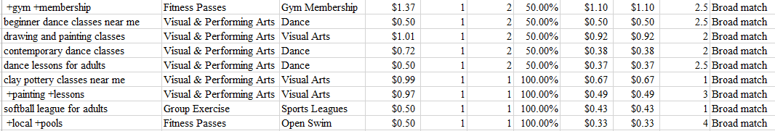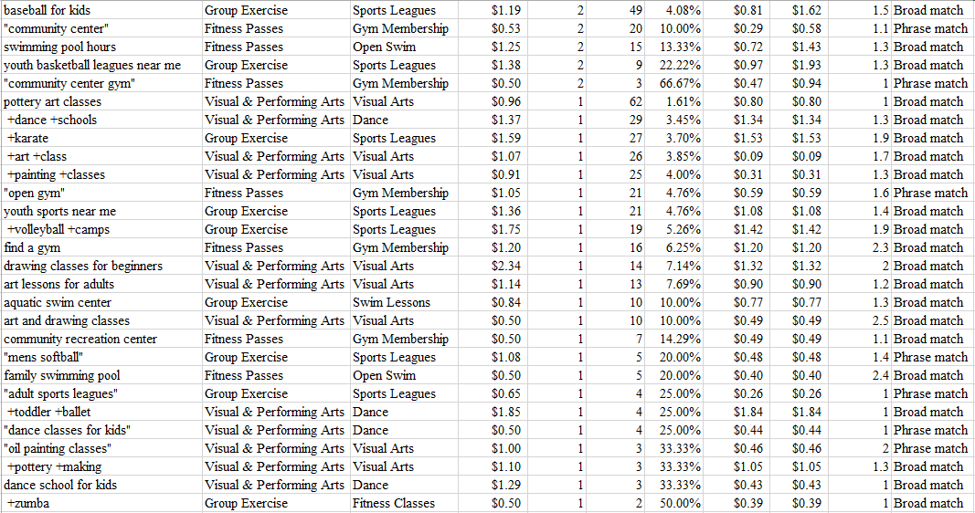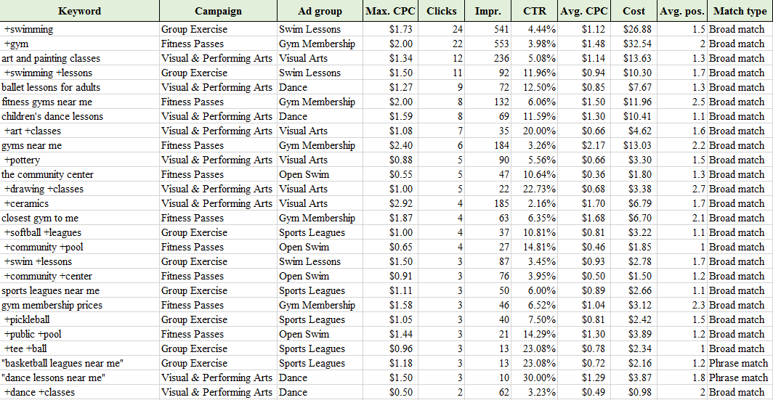**Exhibit #3: Keywords With At Least One Click (March 21 - April 11)**